ACKNOWLEDGEMENT

I would like to take this opportunity to express my deepest gratitude to everyone who contributed directly or indirectly to the successful completion of this project titled “Stock Market Analysis and Forecasting Using Technical Strategies and Deep Learning Models.”
First and foremost, I am profoundly thankful to the open-source communities and contributors who have made tools such as Python, Streamlit, yfinance, TensorFlow, Prophet, ARIMA (Statsmodels), and Matplotlib freely accessible. These libraries and frameworks played a crucial role in the design and implementation of this intelligent stock analysis system. The extensive documentation, community forums, and sample projects provided by these ecosystems helped address several challenges encountered during development.
I am equally grateful for the educational resources, tutorials, and courses available online that helped me build a strong foundation in data science, financial modeling, and deep learning techniques. Platforms such as GitHub, Stack Overflow, Medium, Towards Data Science, and YouTube provided insights and innovative ideas which were instrumental in enhancing this project.
I would also like to extend my appreciation to Streamlit, an extraordinary Python framework that enabled the development of an interactive and visually appealing dashboard. Its ease of use and quick prototyping capabilities made it possible to build a rich front-end experience for users without the need for traditional web technologies.
Most importantly, I am thankful for the opportunity to explore a real-world problem that bridges finance, machine learning, and user-centered design. This project has helped me grow not just as a developer, but also as a problem-solver and researcher. It has refined my skills in time-series forecasting, backtesting, technical analysis, and performance evaluation in a dynamic domain like the stock market.
This project would not have been possible without the cumulative support of the global developer community, mentors who publish open knowledge, and the ever-evolving field of open-source innovation.

About the Project

The Stock Market Analysis and Forecasting System is a comprehensive and interactive web-based dashboard that enables users to analyze historical stock data, apply technical strategies, and forecast future stock prices using machine learning models. Built using Python and Streamlit, this project aims to provide retail investors, analysts, and students with a visual, data-driven approach to stock trading insights.
This project integrates technical analysis techniques such as RSI, MACD, and Bollinger Bands with deep learning and statistical forecasting models like LSTM, ARIMA, and Prophet to generate short-term price predictions. Alongside historical charts and real-time metrics, the system includes backtesting capabilities and cumulative profit visualization, helping users simulate potential trading outcomes based on different strategies.
What makes this project unique is its modular structure, real-world stock data integration via Yahoo Finance API (yfinance), and user-friendly Streamlit interface that replicates a modern financial dashboard. The goal is to not only visualize data but to transform it into actionable financial signals — bringing the power of data science into the hands of individual traders.
Whether used as an educational tool, a personal analysis platform, or a base for further enhancement (like real-time trading APIs or mobile integration), this project serves as a practical implementation of data-driven decision-making in the field of stock market finance.

TABLE OF CONTENT
Acknowledgement… (i)
About the project… (ii)
Table of Content… (iii)
- Introduction to the Project… 1
  - Abstract… 2
  - Introduction… 3
- Tools & Technology Used… 5
  - Language - Python… 6
  - Python Libraries… 11
2.2.1 yfinance
2.2.2 pandas
2.2.3 numpy
2.2.4 matplotlib
2.2.5 tensorflow
2.2.6 prophet
2.2.7 streamlit
  - Tools - VS Code… 26
  - App Framework- Streamlit… 29
  - Data Sources… 33
- System Design… 34
3.1 Architecture Diagram ................................................................................................... 35
3.2 Module Breakdown ...................................................................................................... 37
3.2.1 Data Collection
3.2.2 Technical Indicator Engine
3.2.3 Strategy Engine
3.2.4 Forecasting Models
3.2.5 Streamlit Dashboard

- Implementation & Snapshots… 54
  - Summary Tab … 55
  - Strategy Tab .................................................................................................................. 48
  - Charts & Indicators Tabs ............................................................................................ 50
  - Forecast Tab (LSTM, ARIMA, Prophet) .................................................................. 52
  - Strategy Backtest & Profit Graph .............................................................................. 54
- Strategy & Models ...................................................................................................... 56
5.1 Technical Strategies (RSI, MACD, Bollinger) ......................................................... 57
5.2 Forecasting Models (LSTM, ARIMA, Prophet) ..................................................... 60
5.3 Trade Backtesting ......................................................................................................... 63
5.4 Cumulative Profit Tracking ....................................................................................... 65
5.5 Model Comparison ........................................................................................................ 66
6. Results & Observations ............................................................................................. 68
6.1 Strategy Profit Results .................................................................................................. 69
6.2 Forecast Accuracy ......................................................................................................... 70
6.3 Visual Analysis ............................................................................................................... 72
7. Conclusion ...................................................................................................................... 74
7.1 Summary ......................................................................................................................... 75
7.2 Challenges Faced .......................................................................................................... 76
7.3 Key Learnings ................................................................................................................. 77
8. Future Scope .................................................................................................................. 78
• Integration with Live Trading APIs
• Mobile Dashboard Version
• Sentiment Analysis
• Multi-Stock Comparison
9. References ..................................................................................................................... 80

CHAPTER – 1

INTRODUCTION TO THE PROJECT

ABSTRACT

INTRODUCTION

ABSTRACT

The dynamic nature of stock markets demands intelligent systems that can help investors make informed decisions based on data-driven insights. This project, titled “AI-Powered Stock Market Analysis and Forecasting System”, is developed to address that very need. It is a unified, interactive platform that offers a blend of traditional technical analysis with modern machine learning-based forecasting models.
The system allows users to:
- Analyze real-time stock data using technical indicators such as Relative Strength Index (RSI), Moving Average Convergence Divergence (MACD), and Bollinger Bands.
- Perform strategy backtesting on historical data to assess profitability.
- Leverage powerful predictive models like LSTM (Long Short-Term Memory networks), ARIMA, and Prophet to forecast stock prices for the next 7 days.
- Interact with a Streamlit-based dashboard that displays all metrics, graphs, and outputs in a user-friendly manner.
By merging financial domain knowledge with data science and AI, this project aims to offer a comprehensive toolkit for traders, data scientists, students, and analysts to understand, explore, and experiment with algorithmic stock analysis.
This system is modular, scalable, and designed with extensibility in mind, making it suitable for academic use, demonstrations, and real-world deployment in simplified trading scenarios.

Keywords: Stock Market, LSTM, ARIMA, Prophet, Streamlit, Python, Technical Indicators, Forecasting, YFinance, Backtesting

INTRODUCTION

The financial markets play a crucial role in the development of modern economies. They serve as the primary mechanism for raising capital, allocating resources efficiently, and enabling both individuals and institutions to invest and generate wealth. Among all segments of the financial markets, the stock market is one of the most dynamic and complex, characterized by fluctuations driven by a wide variety of factors—ranging from company fundamentals and economic indicators to global events and investor psychology.
However, despite the tremendous potential for profitability, participating in the stock market without data-driven analysis can be risky. Traditional methods of stock analysis, while still relevant, are often limited by subjective biases and lack real-time adaptability. In recent years, Artificial Intelligence (AI) and Machine Learning (ML) technologies have transformed the way financial data is processed, enabling the extraction of patterns, trends, and insights that were previously difficult or impossible to detect using manual methods.

This project, titled “AI-Powered Stock Market Forecasting and Strategy Analysis System,” addresses the growing demand for intelligent trading tools by integrating multiple techniques such as technical indicators, time series forecasting models, and deep learning networks into a unified, interactive application. The system is built to analyze historical data, generate buy/sell signals, backtest strategies, and predict future stock prices, all from a simple and user-friendly interface.



Figure 1.1 – Stock Prediction

The application makes use of:
- Technical Indicators such as:
  - Relative Strength Index (RSI) – to identify overbought or oversold conditions,
  - Moving Average Convergence Divergence (MACD) – to determine momentum shifts,
  - Bollinger Bands – to detect volatility and potential reversals.
- Forecasting Models including:
  - LSTM (Long Short-Term Memory) – a deep learning model well-suited for sequential data,
  - ARIMA (AutoRegressive Integrated Moving Average) – a classical statistical time-series model,
  - Prophet – a robust additive regression model developed by Meta for time-series forecasting.
- Real-Time Data sourced from Yahoo Finance via the yfinance Python library.

CHAPTER – 2

Tools & Technology Used

Language – Python
    - Introduction
    - History
    - Uses and Application

Python Libraries
2.2.1 yfinance
2.2.2 pandas
2.2.3 numpy
2.2.4 matplotlib
2.2.5 tensorflow
2.2.6 prophet
2.2.7 streamlit

Tools – VS Code
    - Introduction & History
    - Features

App Framework-Streamlit
    - Introduction & History
    - Features & Editions

Data Sources

LANGUAGE - PYTHON

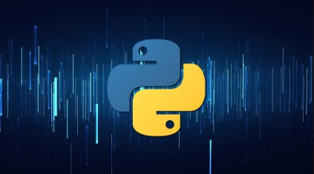

Figure 2.1 - Python Logo

Introduction

Python is a high-level, general-purpose programming language. Its design philosophy emphasized code readability with the use of significant indentation. Python is a dynamically typed language and garbage-collected. It supports multiple programming paradigms, including structure (particularly procedural), object-oriented and functional programming. It is often described as a “battery included” language due to its comprehensive standard library.
The programming language's name ‘Python’ came from the BBC Comedy series “Monty Python’s Flying Circus”. Guido van Rossum thought he needed a name that was short, unique and slightly mysterious and so he decided to name the programming language as ‘Python’. Guido van Rossum began working on Python in the late 1980’s as a successor to the ABC programming language and first released it in the year 1991 as Python 0.9.0. Python 2.0 was released in the year 2000 and introduced new features such as list comprehensions, cycle-detecting garbage collection, reference counting, and Unicode support.

Python 3.0, released in the year 2008, was a major revision that is not completely backward-compatible with earlier versions. Python 2 was discontinued with version 2.7.18 in 2020. Python consistently ranks as one of the most popular programming languages.
A common neologism in the Python community is pythonic, which has a wide range of meaning related to program style. “Pythonic” code may use Python idioms well, be natural or show fluency in the language, or conform with Python’s minimalist philosophy and emphasis on readability. Code that is difficult to understand or reads like a rough transcription from another programming language is called unpythonic. Python users and admirers, especially those considered knowledgeable or experienced, are often referred to as Pythonistas.
Most Python implementations (including CPython) include a read–eval–print loop (REPL), permitting them to function as a command line interpreter for which users enter statements sequentially and receive results immediately. Python also comes with an integrated development environment (IDE), called IDLE, which is more beginner-oriented. Other shells, including IDLE and IPython, add further abilities such as improved auto-completion, session state retention and syntax highlighting.
As well as standard desktop integrated development environments, there are Web browser-based IDEs, including SageMath, for developing science- and math-related programs; PythonAnywhere, a browser-based IDE and hosting environment; and Canopy IDE, a commercial IDE emphasizing scientific computing.
Python's development practices have also been emulated by other languages. For example, the practice of requiring a document describing the rationale for, and issues surrounding, a change to the language (in Python, a PEP) is also used in Tcl, Erlang, and Swift.

History

Python was conceived in the late 1980s by Guido van Rossum at Centrum Wiskunde & Informatica (CWI) in the Netherlands as a successor to the ABC programming language, which was inspired by SETL, capable of exception handling and interfacing with the Amoeba operating system. Its implementation began in December 1989. Van Rossum shouldered sole responsibility for the project, as the lead developer, until 12 July 2018, when he announced his "permanent vacation" from his responsibilities as Python's "benevolent dictator for life", a title the Python community bestowed upon him to reflect his long-term commitment as the project's chief decision-maker. In January 2019, active Python core developers elected a five-member Steering Council to lead the project.
Python 2.0 was released on 16 October 2000, with many major new features. Python 3.0, released on 3 December 2008, with many of its major features backported to Python 2.6.x and
2.7.x. Releases of Python 3 include the 2 to 3 utility, which automates the translation of Python 2 code to Python 3. Python 2.7's end-of-life was initially set for 2015, then postponed to 2020 out of concern that a large body of existing code could not easily be forward-ported to Python 3. No further security patches or other improvements will be released for it.] With Python 2's end-of-life, only Python 3.6.x and later were supported. Later, support for 3.6 was also discontinued. In 2021, Python 3.9.2 and 3.8.8 were expedited as all versions of Python (including 2.7) had security issues leading to possible remote code execution and web cache poisoning.
In 2022, Python 3.10.4 and 3.9.12 were expedited and so were older releases including 3.8.13, and 3.7.13 because of many security issues. When Python 3.9.13 was released in May 2022, it was announced that the 3.9 series (joining the older series 3.8 and 3.7) will only receive security fixes going forward. On September 7, 2022, four new releases were made due to a potential denial-of-service attack: 3.10.7, 3.9.14, 3.8.14, and 3.7.14.

Uses & Applications

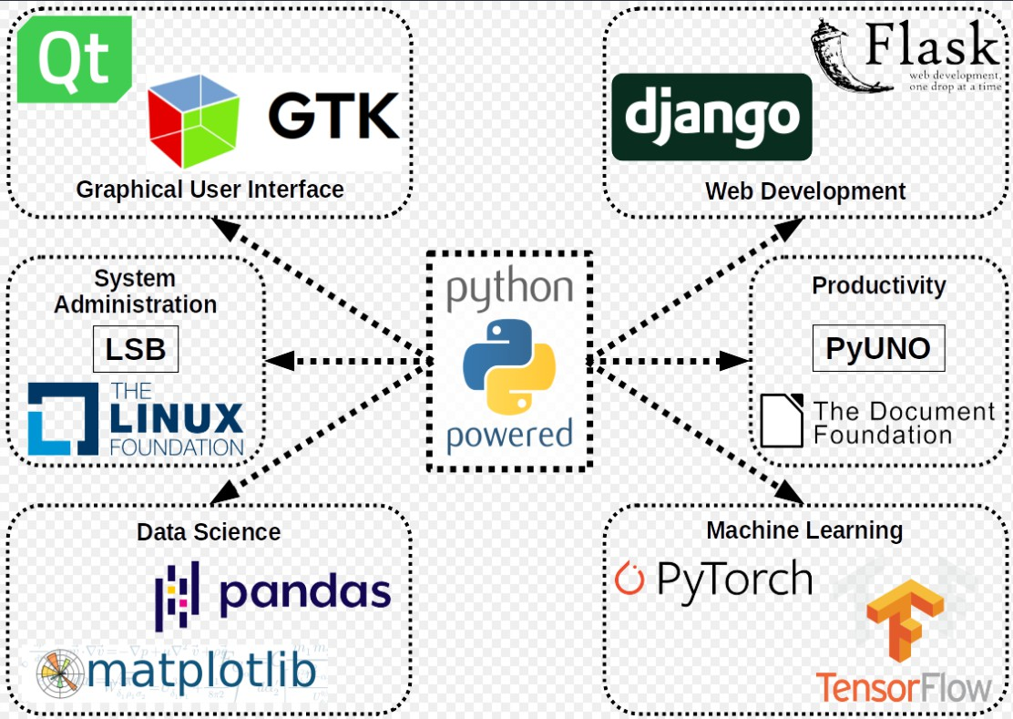

Figure 2.2 - Uses of Python

Python can serve as scripting for web applications, e.g., via mod_wsgi for the Apache web server. With Web Server Gateway Interface, a standard API has evolved to facilitate these applications. Web Frameworks like Django, Pylons, Pyramids, TurboGears, Web2py, Tornado, Flask, Bottle, and Zope support developers in the design and maintenance of complex applications. Pyjs and IronPython can be used to develop the client-side of Ajax-based applications. SQLALchemy can be used as a data mapper to a relational database. Twisted is a framework to program communications between computers, and is used (for example) by Dropbox.

Libraries such as Numpy, Scipy, and Matplotlib allow the effective use of Python in scientific computing, with specialized libraries such as Biopython and Astropy providing domain-specific functionality. SageMath is a computer algebra system with a notebook interface programmable in Python: its library covers many aspects of mathematics, including algebra, combinatorics, numerical mathematics, number theory, and calculus.
OpenCV has Python bindings with a rich set of features for computer vision and image processing. Python is commonly used in artificial intelligence projects and machine learning projects with the help of libraries like TensorFlow, Keras, Pytorch, and Scikit-Learn. As a scripting language with a modular architecture, simple syntax, and rich text processing tools, Python is often used for natural language processing.Python can also be used to create games, with libraries such as Pygame, which can make 2D games.

PYTHON LIBRARIES

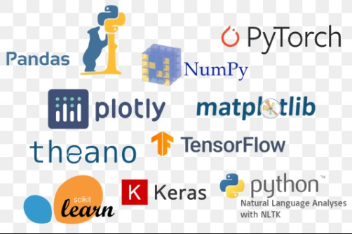

Figure 2.3 - Python Libraries

Normally, a library is a collection of books or is a room or place where many books are stored to be used later. Similarly, in the programming world, a library is a collection of precombined codes that can be used later on in a program for some specific well-defined operations. Other than pre-compiled codes, a library may contain documentation, configurable data, message templates, classes, and values, etc.
A Python library is a collection of related modules. It contains bundles of code that can be used repeatedly in different programs. It makes Python Programming simpler and convenient for the programmers. As we don’t need to write the same codes again and again for different programs. Python libraries play a very vital role in fields of Machine Learning, Data Science, Data Visualization, etc.

As stated above, a Python library is simply a collection of codes or modules of codes that we can use in a program for specific operation. We can use the library so that we don’t need to write the code again in our program that is already available (Do Not Reinvent the Wheel). But how it actually works in practical life. Actually, in the MS Windows environment, the library files have a DLL extension (Dynamic Load Libraries). When we link a library with our program and run that program, the linker automatically searches for that library. It extracts the functionality of that library and interprets the program accordingly. That’s how we use the method of a library in our program.
Python also provides a standard library known as Python Standard Library containing the exact syntax, semantics, and token of Python. It contains built-in modules that provide access to basic system functionality like I/O and some other core modules. Most of the Python Library is written in C programming language. The Python standard library consists of more than 200 modules. All these work together to make Python a high-level programming language. Python Standard Library plays a very important role. Without it, the programmers can’t have access to the functionalities of Python. But other than this, there are several other libraries in Python that make programmer’s lives easier.

yfinance



Figure 2.4 - yfinance

Introduction

yfinance is an open-source Python library designed to streamline the process of retrieving financial market data from Yahoo Finance. Without the need for API keys or complex authentication flows, it allows analysts and developers to programmatically access both historical and intraday quotes, corporate actions (dividends, splits), and a wealth of company metadata (market capitalization, P/E ratio, sector classifications, and more). Under the hood, yfinance emulates browser requests to Yahoo Finance’s undocumented JSON and CSV endpoints, then coerces the raw payloads into idiomatic pandas DataFrames and Python dictionaries.

Because it builds directly on pandas, yfinance slots seamlessly into existing data-science workflows: you can chain together data retrieval, cleaning, feature engineering, and modeling in a single notebook or script. Its methods—such as .history(), .info, and .options—abstract away tedious HTTP handling, JSON parsing, and date-index alignment. This simplicity makes yfinance particularly valuable for rapid prototyping of quantitative strategies, exploratory data analysis, and even production systems where cost constraints preclude paid data feeds.



By leveraging the breadth of Yahoo Finance’s coverage (from blue-chip equities to ETFs, funds, and many international listings), users gain a “one-stop shop” for most securities they wish to analyze.
- Seamless Python–Yahoo Finance Bridge
Leverages Yahoo Finance’s publicly available JSON/CSV endpoints under the hood, but exposes everything via a pure-Python API—no API keys or OAuth required.
- Pandas-Native DataFrames
Returns historical price series, dividends, splits, and corporate actions as time-indexed pandas DataFrames, ready for resampling, merging, or rolling-window feature engineering.
- Rich Metadata Access
Exposes a .info dictionary on each ticker object containing company profile—market cap, P/E, industry, sector, headquarters, website, and more—so you can join fundamental and price data with a single library.
- Intraday & Multicurrency Support
Pulls not just daily OHLCV (Open/High/Low/Close/Volume), but sub-hourly intervals (e.g. 1-, 5-, 15-minute bars) where available, and seamlessly handles currency-converted quotes for international symbols.

History

Originally published in 2018, yfinance was born out of the need for an open, no-cost alternative to paid market-data APIs. The project’s author wrapped Yahoo Finance’s undocumented REST endpoints in a clean, pandas-friendly interface. Over time, the library has grown—adding support for batch downloads (yf.download()), ticker metadata retrieval (Ticker.info), option chains, and interval customization—while maintaining backward compatibility. Today it boasts tens of thousands of downloads per month and is actively maintained on GitHub.
Feature-Driven Evolution
Over time, contributors layered on support for:
- Dividend & split histories
- Real-time quote streaming (via repeated fetches)
- Options chains & implied volatility data
- Multithreaded batch downloads for thousands of tickers
• Origins in Community “Fix-Yahoo-Finance” Effort
In mid-2017, Yahoo Finance disabled its legacy CSV download API, breaking many data-science workflows. A small group of volunteers on GitHub reverse-engineered the new JSON endpoints under the name fix-yahoo-finance, restoring programmatic access.
• Rebranding to yfinance
In early 2018, developer Ran Aroussi refactored and expanded that codebase into a full Python package, renaming it yfinance on PyPI. It bundled not only historical price downloads but also corporate actions, metadata retrieval, and interval support.
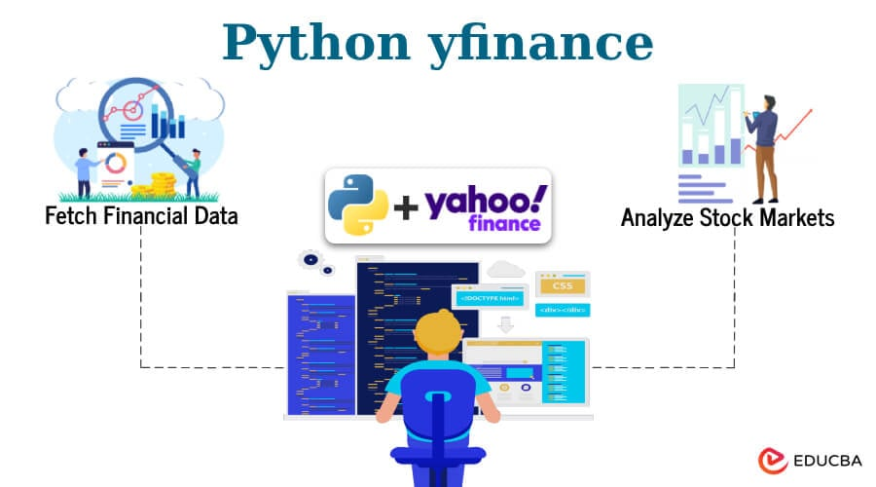

Working and Functionality
The yfinance library acts as a convenient wrapper over Yahoo Finance’s hidden JSON API, allowing developers and analysts to retrieve historical market data, real-time price quotes, financial statements, and other stock-related metadata using simple Python commands. Internally, yfinance sends HTTP requests to specific endpoints on Yahoo’s servers, parses the JSON responses, and formats the results into pandas DataFrames for further analysis. This structure makes it extremely compatible with Python’s broader data-science ecosystem. Users can pull time-series data at different intervals (daily, weekly, etc.), access dividend and split history, retrieve fundamentals like earnings and balance sheets, and even download minute-level intraday data.
Furthermore, yfinance also caches results to minimize repeated API calls, handles corporate events like stock splits and dividends seamlessly, and supports multiple tickers in a single query. It automatically aligns timezone information, adjusts for trading holidays, and allows downloading data in a ready-to-analyze format.
Key Functionalities of yfinance:
- Ticker Module:
The Ticker() object is central to yfinance. It provides access to various methods like .history(), .info, .actions, .dividends, etc.
- Historical Data Download:
  - ticker.history(start, end, interval)
Fetches Open/High/Low/Close/Volume (OHLCV) data over a specified range and granularity.

Company Metadata:
- ticker.info returns company-level information like sector, industry, market cap, PE ratio, and more.
Corporate Actions:
- Use .dividends, .splits, and .actions to view historical dividend payments and stock splits.
Multiple Ticker Support:
- Accepts lists of symbols to pull data in bulk across several companies simultaneously.
Financial Statements:
- Offers .balance_sheet, .financials, and .cashflow for retrieving quarterly and annual reports.
Auto Timezone and Adjustment:
- Automatically adjusts timestamps to reflect correct timezones and handles non-trading days.
Download to CSV:
- Easily export downloaded datasets using pandas' .to_csv() method for offline analysis.
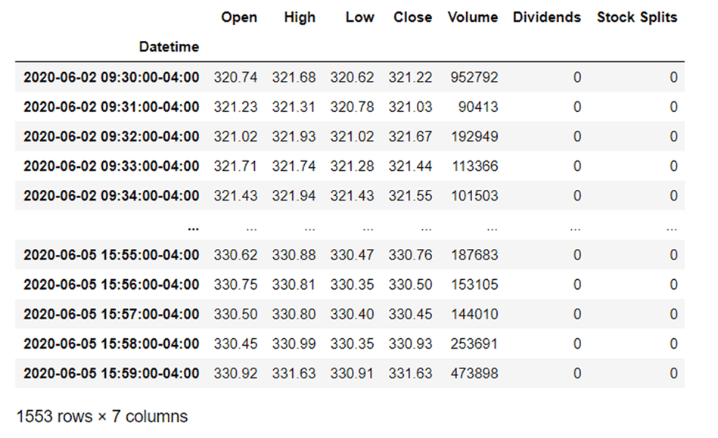

In essence, yfinance abstracts the complexity of financial data retrieval, providing a high-level and reliable interface that supports both beginners and professionals in building robust finance applications.

Application & Uses
Stock Market Analysis and Research:
- Pull historical prices for any stock listed on Yahoo Finance.
- Analyze price patterns, volatility, trends, and support/resistance levels.
Backtesting Trading Strategies:
- Combined with libraries like pandas, numpy, and custom logic, yfinance allows you to simulate how a strategy would have performed historically.
Live Market Dashboards:
- Streamlit + yfinance are often used together to build real-time dashboards showing price movements, charts, and fundamentals.
Machine Learning and Forecasting:
- Supplies the necessary price data to train ML models like LSTM, ARIMA, and Prophet for stock price prediction.
Portfolio Analysis:
- Retrieve time-series data for multiple tickers to monitor and evaluate a diversified investment portfolio.
Academic and Financial Research:
- Frequently used in research papers and university projects for financial data collection and hypothesis testing.
Fundamental Analysis:
- Access financial statements, P/E ratio, market cap, dividend yield, etc., to perform in-depth company evaluations.
Event Detection:
- Analyze stock performance pre- and post-earnings announcements, dividend declarations, or stock splits.
Excel Report Automation:
- Use yfinance with pandas to automate downloading and exporting daily stock data into Excel or CSV reports.
Alternative Data Integration:
- Merge stock data with other external data sources like sentiment analysis, economic indicators, or social media trends.

pandas

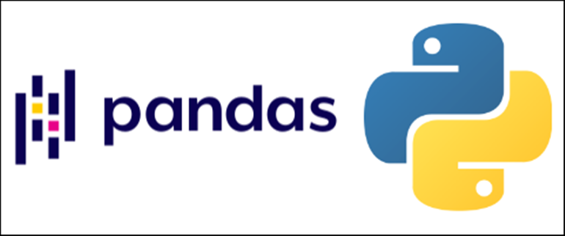

Figure 2.9 - pandas

Introduction

pandas is a fast, powerful, and flexible open-source data analysis and manipulation library built on top of the Python programming language. It provides high-performance, easy-to-use data structures like Series (1D) and DataFrame (2D) that simplify the process of cleaning, transforming, analyzing, and visualizing data.
Used extensively in data science, machine learning, and financial modeling, pandas has become the go-to tool for structured data manipulation. It allows users to load data from various formats (CSV, Excel, SQL, JSON), filter and transform it efficiently, and perform statistical operations — all within a single framework.

🔍 Key Features:
- Tabular data representation through DataFrame objects.
- Intuitive indexing and slicing.
- Powerful groupby operations and pivoting.
- Built-in support for time-series data.
- Merge and join functionality similar to SQL.
- Handling of missing and null data.
- Compatibility with NumPy and Matplotlib for numerical and visual workflows.

Origins in Financial Modeling
The pandas library was initially developed by Wes McKinney in 2008 while working at AQR Capital Management, a quantitative investment firm. At that time, McKinney needed a high-performance, flexible tool to perform quantitative analysis on financial time-series data using Python. No existing package met the requirements, which led him to begin developing what would eventually become pandas.

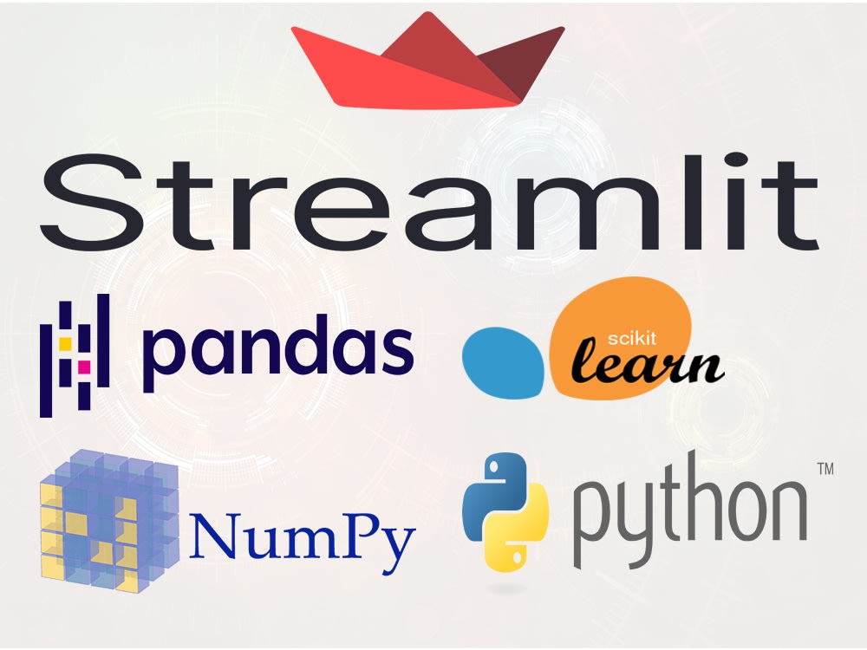

🔄 Open Source Release and Growth
In 2009, McKinney released pandas as an open-source library under the BSD license, allowing it to gain traction rapidly among researchers and analysts. The library filled a crucial gap in Python’s data ecosystem by bringing spreadsheet-like capabilities to a programming environment, particularly suited for structured and tabular data.

📈 Milestones and Releases
- 2008 – Project inception at AQR Capital by Wes McKinney
- 2009 – Open-sourced on GitHub
- 2015 – Became a NumFOCUS affiliated project
- 2020+ – Ongoing performance improvements, support for Apache Arrow, better type hinting, and more user-friendly error messages

2.2.2.3 Working and Functionality
Efficient in-memory representation of labeled, tabular datasets.
Built on top of NumPy, integrating powerful indexing and slicing.
Offers:
- Data cleaning: dropna(), fillna(), replace()
- Grouping: groupby(), pivot tables
- Time-series: resample(), rolling statistics
- File I/O: read_csv(), to_excel(), read_sql()

2.2.2.4 Application and Uses
- Core to data wrangling and feature engineering.
- Used to merge price data with indicators, signals, and forecasts.
- Enables tabular output on Streamlit dashboard.
- Powers summary tables, performance metrics, and trade history export.

2.2.3 numpy
2.2.3.1 Introduction
- numpy is the backbone of scientific computing in Python.
- Provides N-dimensional arrays, mathematical functions, and linear algebra tools.
2.2.3.2 History
- Evolved from Numeric and Numarray.
- Developed in 2006 by Travis Oliphant.
- Basis for most data science and ML libraries.
2.2.3.3 Working and Functionality
- Offers ndarray for fast numerical computation.
- Supports:
  - Broadcasting
  - Vectorized operations
  - Matrix multiplication
  - Random number generation
2.2.3.4 Application and Uses
- Used internally in pandas, sklearn, and TensorFlow.
- Essential for scaling LSTM input and performing time-series reshaping.
- Improves computation speed in indicator and backtest calculations.

2.2.4 matplotlib
2.2.4.1 Introduction
- matplotlib is Python’s standard plotting library for static, interactive, and animated visualizations.
2.2.4.2 History
- Started by John D. Hunter in 2003 to mimic MATLAB plots.
- Today maintained under NumFOCUS.
- Supports multiple backends and rich customization.
2.2.4.3 Working and Functionality
- Core object: pyplot module (plt)
- Plot types: line, scatter, bar, histogram, candlestick
- Customization:
  - plt.title(), plt.xlabel(), plt.grid()
  - Axes formatting, subplots, figure size
- Used in:
  - Signal overlays
  - Forecast charts
  - Profit curves
2.2.4.4 Application and Uses
- Provides key visual outputs for:
  - Technical indicator charts (RSI, MACD, Bollinger)
  - Buy/sell markers
  - Cumulative profit visualizations
  - LSTM and ARIMA forecast lines

2.2.5 tensorflow
2.2.5.1 Introduction
- TensorFlow is a deep learning framework developed by Google for building neural networks.

2.2.5.2 History
- Created by the Google Brain team, open-sourced in 2015.
- One of the most used ML libraries globally.
- Powers many industrial-scale AI applications.

2.2.5.3 Working and Functionality
- Uses tensors and computational graphs.
- Key features:
  - Sequential API for LSTM models
  - GPU/CPU acceleration
  - Model saving and loading
- Syntax:
model = tf.keras.Sequential([
LSTM(50, return_sequences=True),
LSTM(50), Dense(1)
])

2.2.5.4 Application and Uses
- Powers the LSTM model in this project.
- Used for predicting 7-day stock prices.
- Trains on historical data with a look_back window

2.2.6 prophet
2.2.6.1 Introduction
- Prophet is a time-series forecasting tool by Facebook, based on additive models.
2.2.6.2 History
- Released by Facebook’s Core Data Science team in 2017.
- Built for analysts and non-experts in forecasting.
2.2.6.3 Working and Functionality
- Decomposes time-series into trend + seasonality + holiday components.
- Uses fit() and predict() API on pandas DataFrames.
- Handles:
  - Missing data
  - Trend changes
  - Daily, weekly, yearly seasonality
2.2.6.4 Application and Uses
- Used for alternate forecasting to LSTM and ARIMA.
- Helps compare model accuracy and style in dashboard.
- Displays visually appealing, interpretable predictions.

2.2.6 prophet
2.2.6.1 Introduction
- Prophet is a time-series forecasting tool by Facebook, based on additive models.
2.2.6.2 History
- Released by Facebook’s Core Data Science team in 2017.
- Built for analysts and non-experts in forecasting.
2.2.6.3 Working and Functionality
- Decomposes time-series into trend + seasonality + holiday components.
- Uses fit() and predict() API on pandas DataFrames.
- Handles:
  - Missing data
  - Trend changes
  - Daily, weekly, yearly seasonality
2.2.6.4 Application and Uses
- Used for alternate forecasting to LSTM and ARIMA.
- Helps compare model accuracy and style in dashboard.
- Displays visually appealing, interpretable predictions.

TOOLS - VISUAL STUDIO CODE

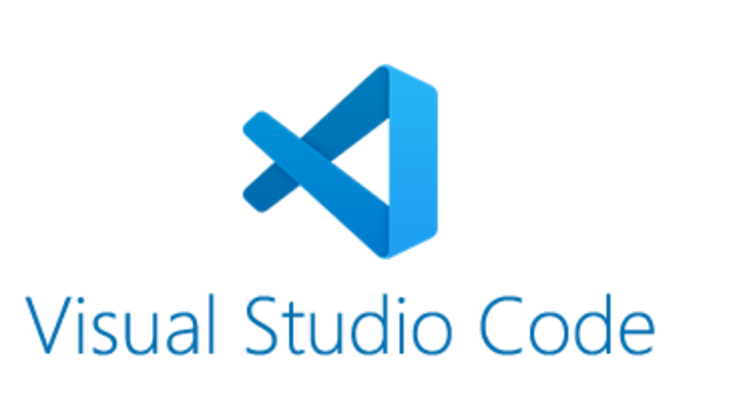

Figure 2.18 - Visual Studio Code Logo

Introduction & History

Visual Studio Code, also commonly referred to as VS Code, is a source-code editor made by Microsoft with the Electron Framework, for Windows, Linux and macOS. Features include support for debugging, syntax highlighting, intelligent code completion, snippets, code refactoring, and embedded Git. Users can change the theme, keyboard shortcuts, preferences, and install extensions that add additional functionality. In the Stack Overflow 2021 Developer Survey, Visual Studio Code was ranked the most popular developer environment tool among 82,000 respondents, with 70% reporting that they use it.

Visual Studio Code was first announced on April 29, 2015, by Microsoft at the 2015 Build conference. A preview build was released shortly thereafter. On November 18, 2015, the source of Visual Studio Code was released under the MIT License, and made available on Github. Extension support was also announced. On April 14, 2016,

Visual Studio Code graduated from the public preview stage and was released to the Web. Microsoft has released most of Visual Studio Code's source code on Github under the permissive MIT License, while the releases by Microsoft are proprietary freeware.
In the 2016 Developers Survey of Stack Overflow, Visual Studio Code ranked No. 13 among the top popular development tools, with only 7% of the 47,000 respondents using it. Two years later, however, Visual Studio Code achieved the No. 1 spot, with 35% of the 75,000 respondents using it. In the 2019 Developers Survey, Visual Studio Code was also ranked No. 1, with 50% of the 87,000 respondents using it. In the 2021 Developers Survey, Visual Studio Code continues to be ranked No. 1, with 70% of the 82,000 respondents using it, rising to 74.48% of the 71,010 responses in the 2022 survey.

Features of Visual Studio Code

Visual Studio Code is a source-code editor that can be used with a variety of programming languages, including Java, Javascript, Go, Node Js, Python, C++, C, Rust and Fortran. It is based on the Electron framework, which is used to develop Node.js web applications that run on the Blink layout engine. Visual Studio Code employs the same editor component (codenamed "Monaco") used in Azure DevOps (formerly called Visual Studio Online and Visual Studio Team Services). Out of the box, Visual Studio Code includes basic support for most common programming languages. This basic support includes syntax highlighting, bracket matching, code folding, and configurable snippets. Visual Studio Code also ships with IntelliSense for JavaScript, TypeScript, JSON, CSS, and HTML, as well as debugging support for Node.js. Support for additional languages can be provided by freely available extensions on the VS Code Marketplace. Instead of a project system, it allows users to open one or more directories, which can then be saved in workspaces for future reuse. This allows it to operate as a language-agnostic code editor for any language. It supports many programming languages and a set of features that

differs per language. Unwanted files and folders can be excluded from the project tree via the settings. Many Visual Studio Code features are not exposed through menus or the user interface but can be accessed via the command palette.
Visual Studio Code can be extended via extensions, available through a central repository. This includes additions to the editor and language support. A notable feature is the ability to create extensions that add support for new languages, themes, debuggers, time travel debuggers, perform static code analysis, and add code linters using the Language Server Protocols. Source control is a built-in feature of Visual Studio Code. It has a dedicated tab inside of the menu bar where users can access version control settings and view changes made to the current project. To use the feature, Visual Studio Code must be linked to any supported version control system (Git, Apache Subversion, Perforce, etc.). This allows users to create repositories as well as to make push and pull requests directly from the Visual Studio Code program.
Visual Studio Code allows users to set the code page in which the active document is saved, the newline character, and the programming language of the active document. This allows it to be used on any platform, in any locale, and for any given programming language. Visual Studio Code collects usage data and sends it to Microsoft, although this can be disabled. Due to the open-source nature of the application, the telemetry code is accessible to the public, who can see exactly what is collected

Appframework-Streamlit

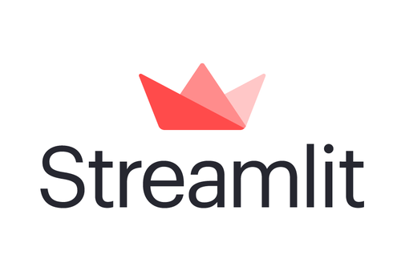

Fig - Streamlit

Introduction & History

Streamlit is an open-source Python framework specifically designed to create interactive, data-driven web applications with minimal effort. Unlike traditional web development tools that require proficiency in HTML, CSS, and JavaScript, Streamlit allows developers—particularly data scientists and machine learning practitioners—to build full-featured web interfaces entirely in Python.
At its core, Streamlit treats a Python script as a reactive UI app: every time the script is modified or a widget is interacted with, the script reruns from top to bottom, updating the app in real-time. This paradigm shift simplifies development and debugging significantly, especially in the context of data analytics and model deployment.
Key Characteristics:
- Minimalist and Pythonic syntax
- Real-time data updates without reloading
- Powerful widget system (buttons, sliders, dropdowns, etc.)
- Seamless integration with common Python libraries (Pandas, NumPy, Matplotlib, TensorFlow, etc.)
- Web-based output suitable for sharing, showcasing, and deployment
Streamlit apps can be run locally or hosted online, making it an ideal choice for internal dashboards, demoing machine learning models, or building lightweight tools for data exploration.

History
The inception of Streamlit traces back to 2019, when it was introduced by a group of engineers and data scientists from Google X and other technology backgrounds. Their core motivation was to address a recurring pain point: turning Jupyter notebooks or Python scripts into interactive apps for stakeholders often required extensive web development knowledge and tools.
Timeline & Evolution:
- October 2019 – First Public Release
Streamlit was publicly launched as an open-source library. Its motto was “The fastest way to build data apps in Python.” The response was overwhelming, especially from the data science and academic communities.
- 2020 – Rapid Adoption
With the rise of machine learning workflows and remote collaboration, Streamlit gained significant traction. It was widely adopted for internal dashboards, hackathons, and research presentations.
- 2021 – Community Growth & Features Expansion
Features like st.tabs, st.download_button, and expanded widget support were introduced. The Streamlit community grew exponentially, with thousands of GitHub stars, contributors, and tutorials emerging worldwide.
- 2022 – Acquisition by Snowflake
Recognizing its potential, Snowflake Inc. acquired Streamlit in 2022, signaling a major shift toward enterprise-ready app deployment and cloud-native analytics integration.
- 2023 – Integration with Large Language Models (LLMs)
Streamlit began evolving into a key tool for AI demos, including integration with ChatGPT, HuggingFace models, and vector databases, enabling developers to rapidly prototype generative AI applications.
- 2024 – Version 1.35+
The framework now supports themes, state management, component plugins, and authentication, making it suitable for both personal and enterprise-grade applications.
Notable Milestones:
- 80k+ GitHub stars (as of 2025)
- 5M+ downloads on PyPI
- 300+ community-contributed components
- Used in projects by Google, Facebook, Uber, and research labs worldwide

Features & Editions

Streamlit was designed with a singular goal: to simplify the creation of interactive web applications for data-driven projects using only Python. Its features empower data scientists and machine learning engineers to move from notebooks to live web apps in minutes—without needing traditional web development skills.

🔹 1. Simple and Pythonic Syntax
- Streamlit allows developers to build UI components like buttons, sliders, and charts using standard Python code.
- There is no need to write HTML, CSS, or JavaScript.
- Syntax is intuitive and declarative, making code easy to read and maintain.

2. Reactive Framework
- Streamlit apps automatically update every time a user interacts with a widget or the script is changed.
- This reactivity mimics spreadsheet-like behavior where output recalculates instantly.
- Developers don’t need to write callbacks or manage complex frontend states.

3. Widget and Input Components
- Rich set of built-in widgets: st.button, st.slider, st.selectbox, st.date_input, st.file_uploader, etc.
- Widgets capture user input and automatically re-render the app based on that input.
- Easily bind widget values to Python variables for use in real-time computatio
4. Data Visualization Support
- Seamless integration with libraries like Matplotlib, Plotly, Altair, Seaborn, Bokeh, and PyDeck.
- DataFrames from Pandas can be rendered as sortable and scrollable tables using st.dataframe and st.table.
- Plots can be annotated and customized within Streamlit’s responsive UI.

5. Layout and Design
- Support for wide vs centered page layouts.
- Use of st.columns, st.expander, and st.tabs to organize content in multiple sections.
- Theming system allows light/dark mode and CSS customization.

6. File Handling and Downloads
- Upload and process files dynamically using st.file_uploader.
- Allow users to download generated files using st.download_button.

7. State Management
- Built-in session state (st.session_state) enables apps to preserve variables across user interactions.
- Useful for maintaining user preferences, caching data, or building multi-step workflows.

8. Caching and Performance
- @st.cache and @st.cache_data decorators allow expensive computations (like model loading or data processing) to be cached for performance.
- Improves responsiveness and reduces redundant processing.

9. Deployment Ready
- Apps can be run locally with a single command: streamlit run app.py
- Supports cloud deployment on platforms like:
  - Streamlit Cloud
  - Heroku
  - Render
  - AWS, GCP, and Azure

10. Community Components & Plugins
- Streamlit supports custom plugins via streamlit.components.v1.
- Community-contributed components include dropdown menus, chat interfaces, image annotators, and more.
- Active ecosystem on GitHub and Discourse forum.

Editions and Hosting Options
🔸 1. Streamlit Open-Source
- The core library available via PyPI (pip install streamlit) is entirely open-source.
- Can be used for local development, internal sharing, and hosted via any cloud platform.
- Community support through forums and GitHub.
🔸 2. Streamlit Community Cloud (Previously Streamlit Sharing)
- Hosted version provided by the Streamlit team.
- One-click deployment of apps by linking a GitHub repo.
- Free tier includes:
  - Live URLs for apps
  - Versioning through Git
  - Built-in user authentication for private apps
🔸 3. Streamlit for Teams (via Snowflake)
- After Streamlit’s acquisition by Snowflake, the framework is now being integrated into enterprise-grade data platforms.
- Streamlit apps can be deployed securely within Snowflake’s data cloud.
- Offers enhanced scalability, security, and team collaboration features.
- Ideal for building internal dashboards and AI/ML-powered apps on company datasets.
🔸 4. Streamlit Embedded (for SaaS Platforms)
- Allows third-party platforms to integrate Streamlit components inside their own UIs.
- Enables white-labeled, modular applications.

2.4.4 Working & Architecture of Streamlit
Streamlit is built on a reactive programming model that treats Python scripts like workflows. It transforms Python scripts into dynamic web applications by watching the script’s execution from top to bottom and re-executing them whenever user input changes. This model eliminates the need for callbacks or frontend logic.
At its core, Streamlit follows a stateless re-run architecture, which makes the entire app reactive and automatically updatable.

🔁 Execution Flow: Step-by-Step
1. User Opens the App
The user launches the app using the command:
streamlit run app.py
This starts a local web server and opens a browser tab.

2. Script Executes from Top to Bottom
The Python script runs linearly like a normal Python script.
- Data is fetched or generated
- Charts are drawn
- Widgets are displayed
- Layout is built

3. Widgets Get Rendered
UI components such as st.slider(), st.button(), or st.text_input() are rendered in the browser. Streamlit assigns them IDs and binds them to their return values.

4. User Interacts with a Widget
When a user clicks a button or changes a slider, Streamlit captures that event in the background.

5 Script Re-Executes Automatically
Upon any widget interaction, the entire script re-runs from the top, using the updated state of widgets. This ensures the output is always in sync with the inputs—without requiring any callback mechanism.
- Results Re-rendered in Browser
New charts, values, tables, or predictions are rendered in the frontend. Old outputs are replaced with new ones automatically.
🧩 Key Architectural Components
1. App Runner
- Executes Python code line-by-line each time an input changes.
- Maintains minimal state using session and caching.
2. Frontend UI Engine
- Built on React.js, Tornado, and WebSocket.
- Handles live updates, rendering, and responsiveness of widgets.
- Ensures real-time reflection of backend changes on the UI.
3. Session State
- Preserves user-specific data between interactions (e.g., form input, counters).
- Managed via st.session_state.
4. Streamlit Widgets
Each widget stores and returns a value.
Widget values are bound directly to Python variables (e.g., slider_val = st.slider(...)).
5. Caching Layer
@st.cache_data and @st.cache_resource prevent redundant computations.
Ideal for API calls, model loading, or data processing.

⚙️ Streamlit Architecture Diagram
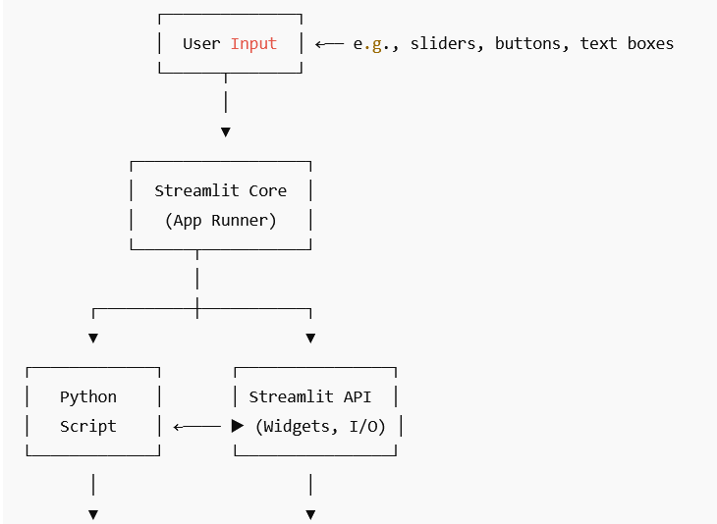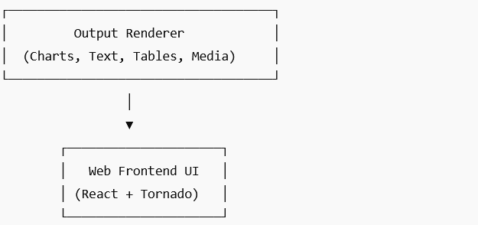

Data Sources

In this project, accurate and up-to-date stock data is fundamental for all analysis, forecasting, and visualization tasks. The primary data source used is Yahoo Finance, accessed programmatically using the yfinance Python library.

📊 1. Yahoo Finance
Yahoo Finance is a widely trusted platform for financial data, offering historical and real-time stock price information, technical indicators, company fundamentals, and market summaries.
🔹 What Data Was Used:
- Stock Price History:
  - Open, High, Low, Close (OHLC)
  - Adjusted Close
  - Volume
  - Date-wise indexed
- Company Fundamentals (via yfinance):
  - Company name, industry
  - Market cap, PE ratio
  - 52-week high/low
  - Headquarters location
  - Website URL
  - Business summary
🔹 Data Frequency:
- Daily interval was used, with around 1 year of historical data per selected stock.
🔹 Access Method:
- The yfinance.Ticker(<TICKER>) object provides:
  - .history(period="1y") → Historical price data
  - .info → Fundamental metadata
🔹 Examples of Stocks Analyzed:
- META (Meta Platforms Inc.)
- INFY (Infosys Ltd.)
- TATASTEEL, RELIANCE, and others (user-selectable)

🧠 2. Internally Generated Data
Beyond the external data fetched from Yahoo Finance, this project also creates multiple internal datasets during processing and analysis. These internally generated components serve as the core of our strategy evaluation and forecasting capabilities.
First, technical indicators such as Relative Strength Index (RSI), Moving Average Convergence Divergence (MACD), Bollinger Bands, Simple Moving Average (SMA), and Exponential Moving Average (EMA) are calculated using the technical_indicator.py module. These indicators help in identifying potential trading opportunities and understanding market momentum.
Next, trading strategies are applied to the processed data. These include RSI-based signals, MACD crossovers, and Bollinger Band breakouts, each implemented in separate strategy files. These modules output a series of buy and sell signals that can be backtested.
The backtesting process, carried out in the backtest_strategy.py file, simulates historical trades based on the strategy signals and logs detailed information such as the type of trade, entry/exit dates, price, and profit. This produces a structured trade history used for both performance evaluation and export.
Furthermore, each strategy execution computes the cumulative profit over time, providing a visual trajectory of how the strategy would have performed. This is particularly useful for comparing different strategies on the same stock.
Finally, our system incorporates machine learning and statistical forecasting models like LSTM, ARIMA, and Prophet, each generating a 7-day future price prediction based on historical trends. These predictions are plotted and displayed as separate visual outputs, helping users understand near-term price expectations.
By combining high-quality external stock market data with well-structured internally generated indicators, strategies, and forecast models, the project ensures a comprehensive and data-rich environment for decision-making and analysis.

CHAPTER - 3

System Design

Architecture Diagram

Module Breakdown

Data Flow & pipeline

Architecture Diagram
The system architecture of the Stock Forecasting and Strategy Dashboard is designed as a modular pipeline that integrates data acquisition, processing, strategy application, forecasting, and visualization. The architecture ensures a smooth flow of data and allows for flexible plug-and-play enhancements in forecasting models or technical indicators.

🔧 Component Descriptions:
- Streamlit UI
The front-end dashboard handles all user interactions, including input selection (ticker, strategy, dates), and displays results in multiple tabs (Summary, Strategy, Forecast, etc.).
- Data Acquisition
Uses the yfinance library to fetch historical stock data from Yahoo Finance based on the selected ticker and date range.
- Technical Indicator Engine
Adds calculated columns like RSI_14, MACD, SMA_20, EMA_14, etc., which are required for generating trading signals.
- Strategy Engine
Based on the selected strategy (RSI, MACD, or Bollinger), generates buy/sell signals using logic defined in modular strategy files.
- Backtesting Module
Simulates trades based on signals and calculates cumulative profits, trade count, and other performance metrics. Also prepares trade history for download.
- Forecasting Models
Depending on user selection (LSTM, ARIMA, or Prophet), this module predicts future stock prices for the next 7 days. Each model uses a different approach (deep learning, statistical, or additive time series).
- Result Visualization
Generates dynamic plots including candlestick charts, indicator overlays, cumulative profit curves, and forecast graphs. Trade history is also downloadable as CS

📊 Architecture Diagram:

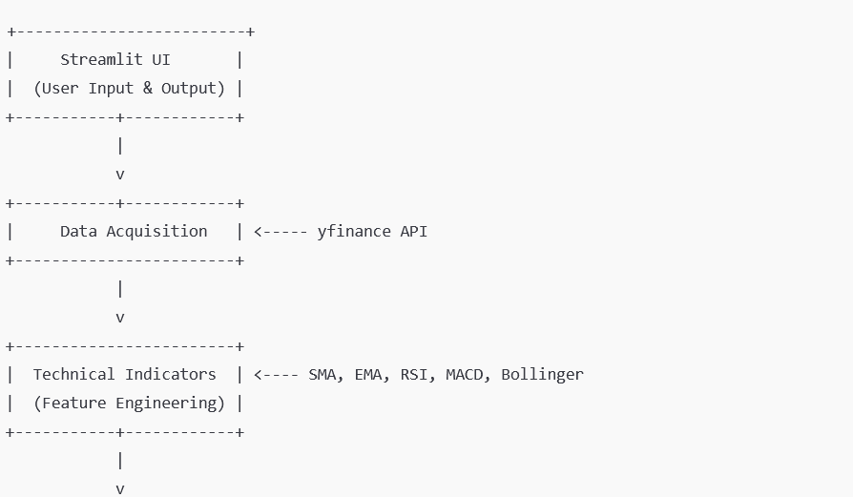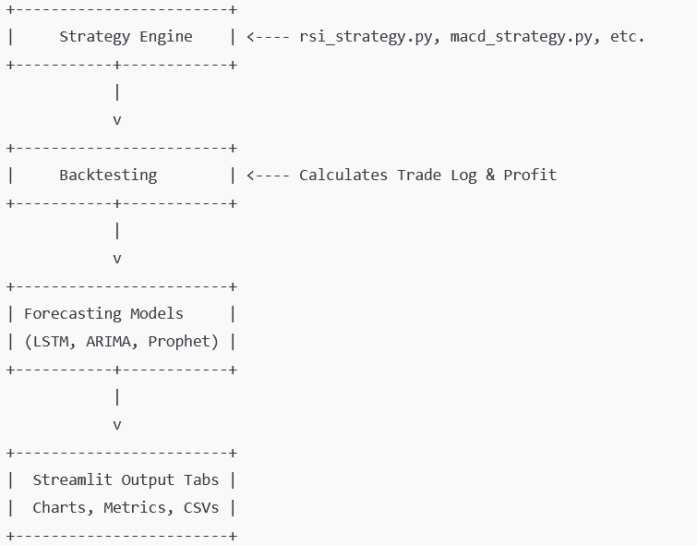

🧩 High-Level Overview:
The architecture consists of the following major components:
- User Interface (Streamlit Dashboard)
- Data Acquisition Layer
- Data Preprocessing & Indicator Engine
- Strategy Engine (RSI, MACD, Bollinger)
- Backtesting Module
- Forecasting Models (LSTM, ARIMA, Prophet)
- Result Visualization & Export

3.2 Module Breakdown
The stock analysis and forecasting system is built using a modular architecture, where each component is responsible for a distinct part of the process—from data gathering to user interaction. This separation of concerns enhances scalability, flexibility, and maintainability of the system. Below is a detailed explanation of each major module:

3.2.1 Data Collection Module
This module serves as the foundational layer of the system by fetching real-time and historical stock data from external sources. In this project, the yfinance library is used to collect data from Yahoo Finance. The collected data includes:
- Daily Open, High, Low, Close, and Volume (OHLCV)
- Market capitalization
- Stock metadata (e.g., PE ratio, 52-week high/low)
- Timestamped data suitable for time series analysis
Key features of this module include:
- Custom date range selection by the user
- Ticker flexibility (any valid listed symbol)
- Automatic handling of missing or incomplete records
This module ensures that all subsequent analytics and predictions are based on accurate and up-to-date financial data.

3.2.2 Technical Indicator Engine
Once the raw stock data is obtained, it is passed to the Technical Indicator Engine for enhancement. This module computes commonly used financial indicators that help in identifying trading signals and understanding stock trends. Indicators integrated in this system include:
- Simple Moving Average (SMA)
- Exponential Moving Average (EMA)
- Relative Strength Index (RSI)
- Moving Average Convergence Divergence (MACD)
- Bollinger Bands
These indicators are implemented using pandas, numpy, and basic statistical operations. The output is a DataFrame enriched with indicator columns, which forms the input to the Strategy Engine.
Benefits:
- Enhances raw data with trader-relevant context
- Allows comparative analysis between multiple indicators
- Supports dynamic window sizes and thresholds for each indicator

3.2.3 Strategy Engine
This module interprets the technical indicators and generates actionable trading signals (Buy/Sell). It implements rule-based algorithms to identify optimal entry and exit points.
Supported strategies:
- RSI Strategy: Buys when RSI < 30 and sells when RSI > 70
- MACD Strategy: Triggers trades based on MACD crossover logic
- Bollinger Band Strategy: Detects overbought and oversold conditions using band breakouts
Each strategy is designed as a plug-and-play Python function, allowing flexibility and easy addition of future strategies.
Capabilities:
- Backtesting: Evaluates strategy performance over historical data
- Trade tracking: Maintains a log of buy/sell signals, profits, and timestamps
- Scalability: Additional strategies can be integrated without disrupting the system

3.2.4 Forecasting Models
This module is responsible for predicting future stock prices based on historical trends. Three advanced time series models have been implemented:
- LSTM (Long Short-Term Memory):
  - A deep learning model from the RNN family
  - Trained using tensorflow and keras
  - Captures long-term dependencies in stock price movement
  - Predicts the next 7 days’ closing prices
- ARIMA (AutoRegressive Integrated Moving Average):
  - A statistical model using statsmodels
  - Ideal for stationary time series
  - Fits a linear model on past data to forecast future values
- Prophet:
  - A model developed by Facebook
  - Handles seasonality, holidays, and irregular trends
  - User-friendly API and robust against missing data
Each model takes the cleaned data as input and outputs 7-day forecasts, which are then visualized using Matplotlib and integrated into the Streamlit dashboard.

3.2.5 Streamlit Dashboard (User Interface Layer)
This is the interactive layer of the system, allowing users to:
- Input stock ticker and date range
- Choose technical strategy and forecasting model
- Visualize performance, signals, and predictions
Streamlit provides a modern UI with tabs, metrics, buttons, and charts. Key features include:
- Tab-based navigation: Summary, Charts, Indicators, Forecast, Strategy
- Buy/Sell visualization with marker overlays
- Downloadable trade logs
- Cumulative profit graphs
- Dynamic charting and responsive layout
This layer transforms a complex backend into a user-friendly platform suitable for both casual investors and data-savvy analysts

CHAPTER - 4

Implementation & Snapshots

Below is a walk-through of the complete end-to-end implementation, showing how raw data flows through the Python back-end, is enriched by analytics pipelines, and finally appears inside a multi-tab Streamlit dashboard.

4.1 Overall Execution Flow

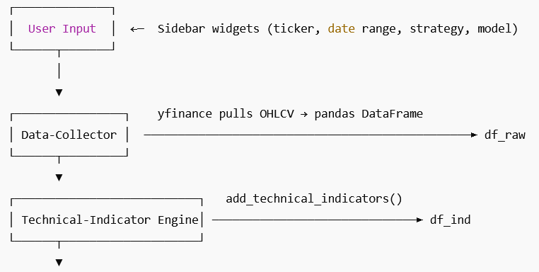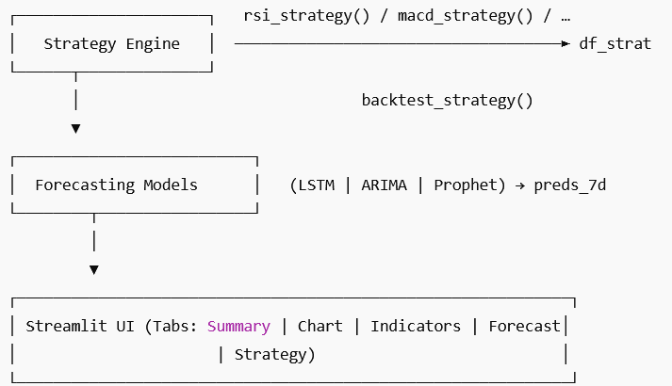
4.2 Streamlit Layout & Core Code

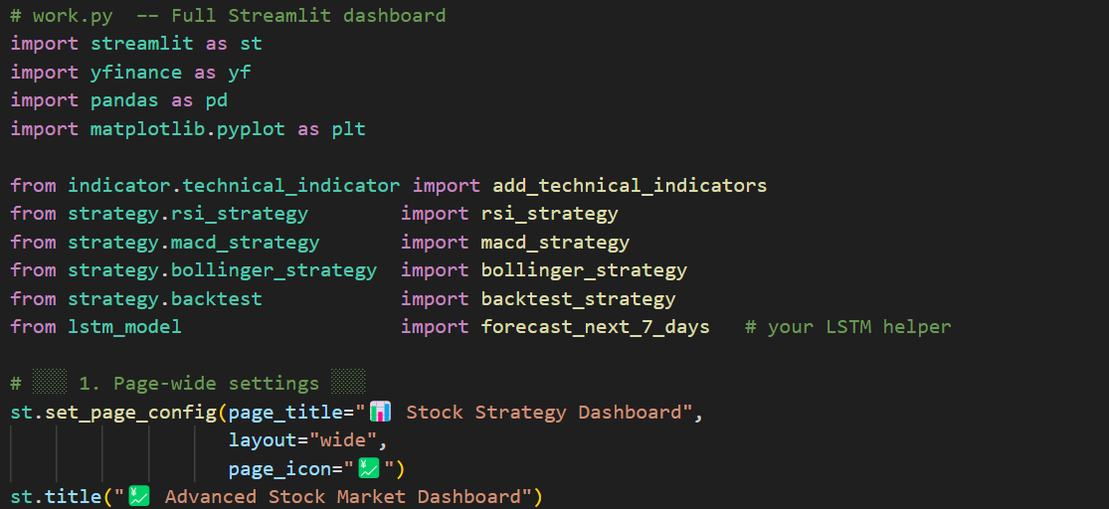

A sidebar gathers user choices:
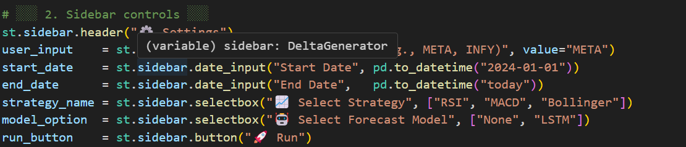

When Run is clicked the pipeline executes and five tabs are built:

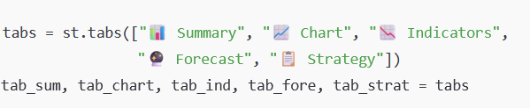

4.3 Tab-by-Tab Walk-through

4.3.1 “Summary” Tab
Shows high-level company and session metrics.

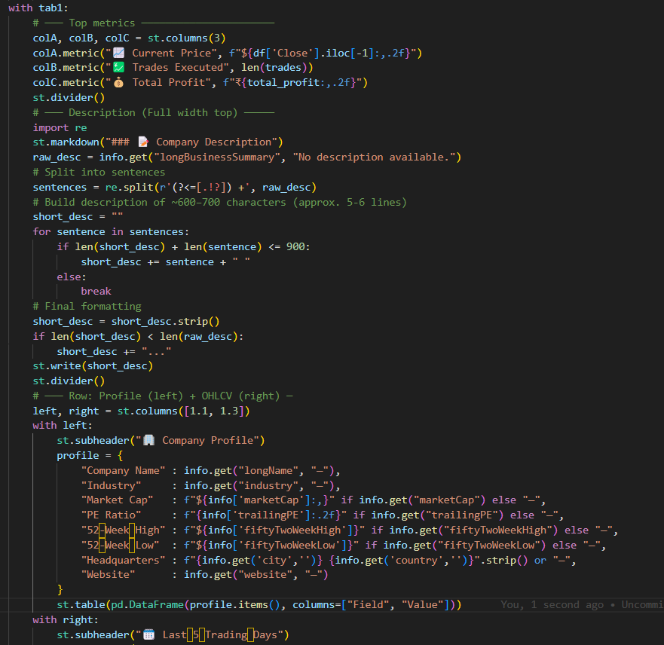

4.3.2 “Chart” Tab
Displays raw closing-price history plus Buy/Sell markers if a strategy is selected.

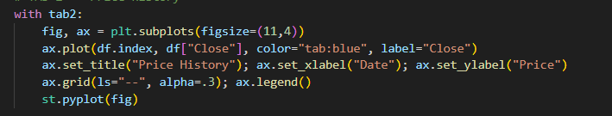

4.3.3 “Indicators” Tab
Shows the enriched DataFrame tail plus quick plots

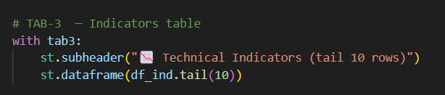

4.3.4 “Forecast” Tab
Runs the chosen model and visualizes both full and zoomed-in 7-day predictions.

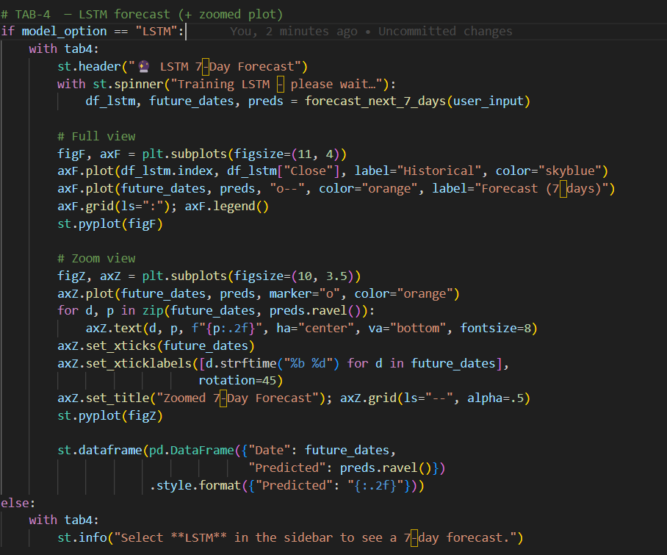

4.3.5 “Strategy” Tab
Trade ledger, cumulative P&L curve, CSV download.

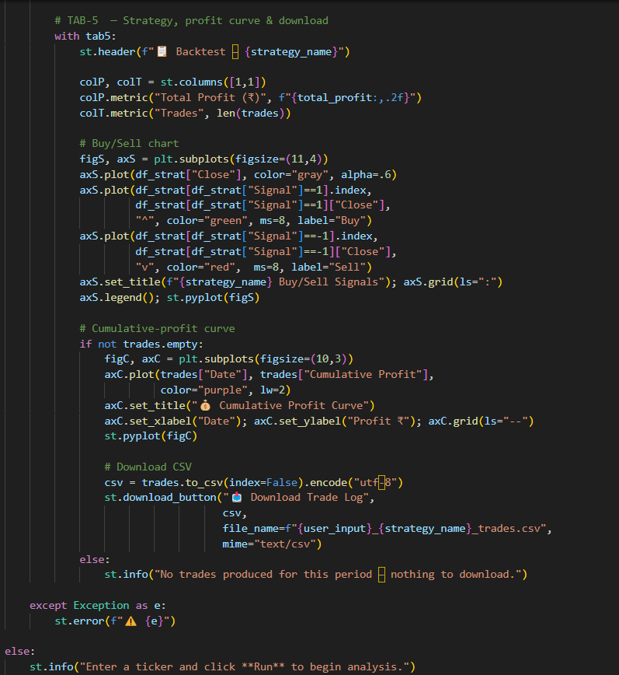

4.5 Key Take-Aways

- Modularity – Each tab calls only the functions it needs, so adding a new strategy or indicator means touching one module, not the entire codebase.
- Live Interactivity – Streamlit re-runs from top to bottom on every widget change, keeping UI reactive without extra callbacks.
- Ease of Distribution – The whole dashboard can be deployed on Streamlit Cloud or any Docker-based PaaS within minutes.

CHAPTER - 5

Strategy & Models

This chapter delves into the heart of the system’s decision-making pipeline, outlining both traditional technical trading strategies and modern predictive models. It explains the theory, implementation, and evaluation of each strategy used in the application, ensuring a comprehensive understanding of how stock trading decisions are simulated and visualized.

5.1 Technical-Indicator Strategies
Technical strategies help traders identify potential buy or sell opportunities using mathematical indicators derived from historical price data. In this project, three widely-used and time-tested strategies have been implemented: RSI, MACD, and Bollinger Bands.
The Relative Strength Index (RSI) is a momentum oscillator that measures the speed and change of price movements. It ranges from 0 to 100 and typically indicates overbought conditions when above 70, and oversold conditions when below 30. The RSI strategy used here generates a buy signal when RSI dips below 30 and a sell signal when it rises above 70.
The MACD (Moving Average Convergence Divergence) strategy identifies changes in the strength, direction, momentum, and duration of a trend. It uses the difference between two exponential moving averages (12-day and 26-day) and a signal line (9-day EMA of the MACD). A buy signal is triggered when the MACD line crosses above the signal line, and a sell signal occurs when it crosses below.
Bollinger Bands measure market volatility by placing upper and lower bands at a certain number of standard deviations around a moving average. The strategy generates a buy signal when the stock price drops below the lower band (indicating potential undervaluation), and a sell signal when it rises above the upper band.
Each strategy is coded with clear signal rules and applied across historical data to generate buy/sell points. These signals are used to simulate trading behavior and compare the profitability of each strategy. 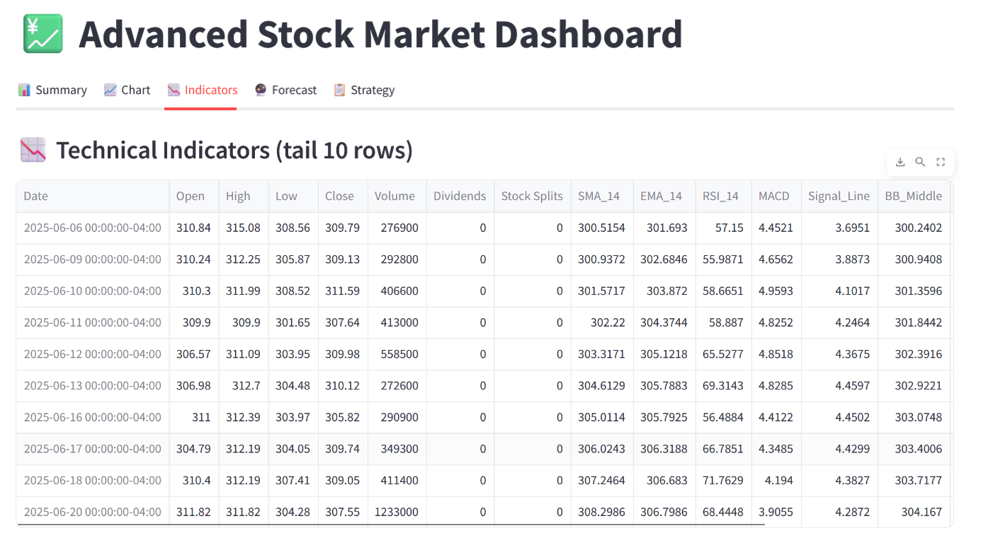

5.2 Forecasting Models
In addition to traditional strategies, the system includes predictive modeling capabilities using three distinct forecasting methods: LSTM, ARIMA, and Prophet. These models attempt to predict the next seven days of stock prices based on historical trends and patterns.
The LSTM (Long Short-Term Memory) model is a type of recurrent neural network capable of learning order dependencies in sequence prediction problems. It processes historical stock prices over a look-back window (typically 60 days), scales the data, and predicts future prices in a recursive fashion. LSTM is particularly suited for time-series forecasting due to its ability to retain memory over long sequences.
ARIMA (Auto-Regressive Integrated Moving Average) is a classical statistical model used for time-series forecasting. It uses past values and the relationship between them to model future values. In this system, ARIMA is configured to automatically adjust for non-stationarity and is well-suited for short-term prediction tasks due to its speed and interpretability.
Prophet, developed by Meta (Facebook), is an open-source forecasting tool designed to handle time-series data with strong seasonal effects. It is robust to missing data and shifts in trends, making it ideal for financial data. Prophet decomposes the time-series into trend, seasonality, and holiday components to generate accurate and interpretable forecasts.
Each forecasting model produces a 7-day forward-looking price prediction, which is visualized in both full-range and zoomed-in plots. These visual aids help users understand the predicted market direction and make informed decisions.
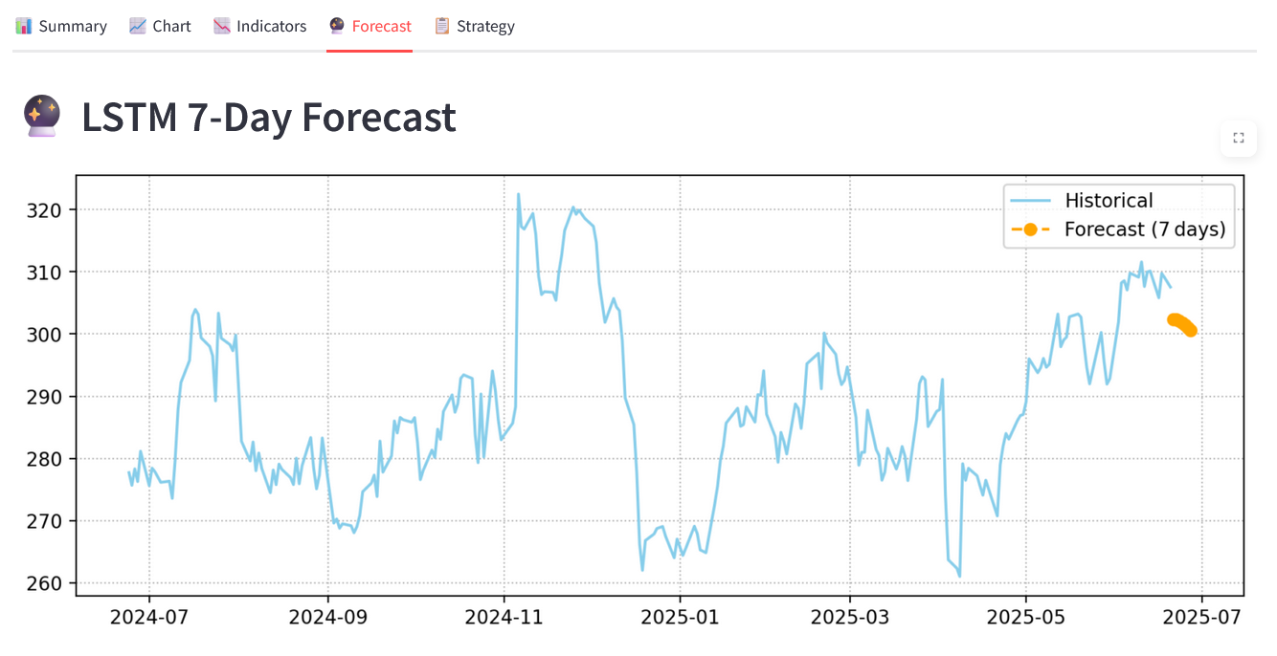
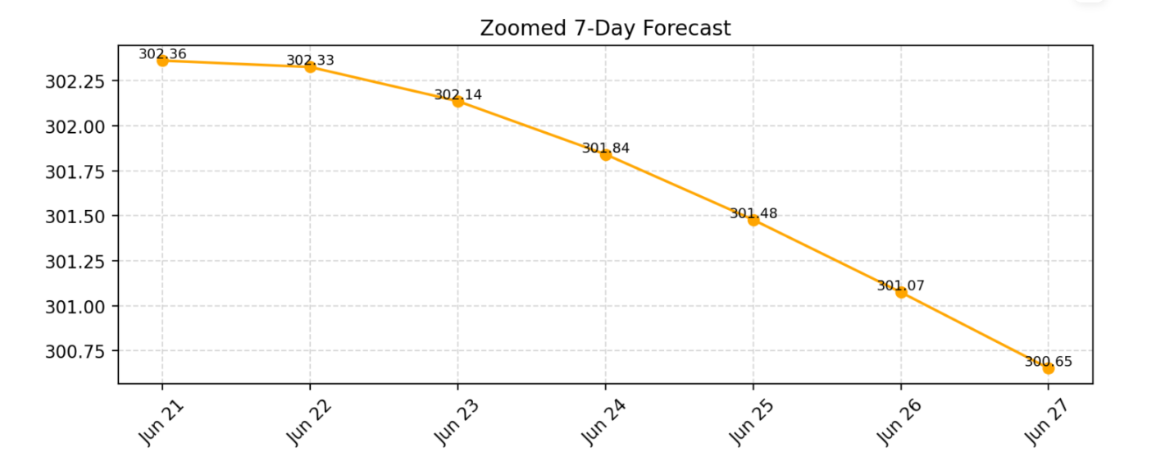
5.3 Trade Backtesting
To evaluate the effectiveness of trading strategies, a backtesting module is implemented. This module simulates the buying and selling of stocks based on the generated signals and calculates the resulting profit or loss.
When a buy signal is detected, the system simulates purchasing the stock with a fixed amount of capital (e.g., ₹1000). Upon the next sell signal, the stock is sold, and the profit or loss is recorded based on the percentage change in price. This cycle repeats throughout the historical data, building a ledger of all trades.
Backtesting is crucial for validating strategies before applying them in live markets. It ensures that strategies are not just theoretically sound but also practically profitable. The module also avoids look-ahead bias and ensures trades are executed in a realistic, rule-based manner.
The output includes the number of trades executed, individual profits from each trade, and the total profit. This data is displayed in the application and can be exported for further analysis.
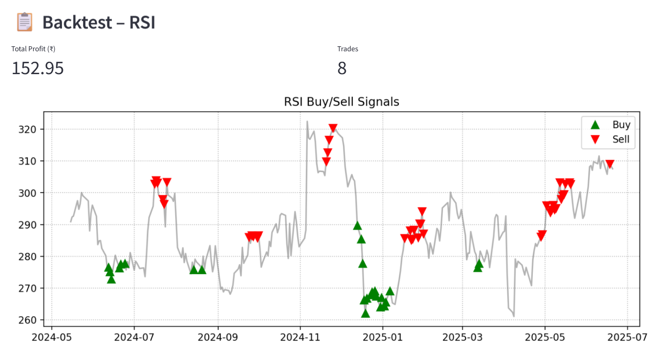
5.4 Cumulative Profit Tracking
To provide a visual representation of strategy performance over time, the system includes a cumulative profit tracker. This tracker sums the profit or loss from each trade sequentially and plots the result to show the overall trend in profitability.
The resulting graph provides a clear indication of how the strategy performs across different market conditions. A steadily rising curve indicates consistent profits, while a flat or declining curve may signal periods of inactivity or loss.
This visualization helps users assess the long-term viability of a strategy. It highlights key performance aspects such as drawdowns, recovery periods, and compounding profits. For portfolio managers and researchers, such a curve offers deep insights into risk-adjusted returns and strategy robustness.
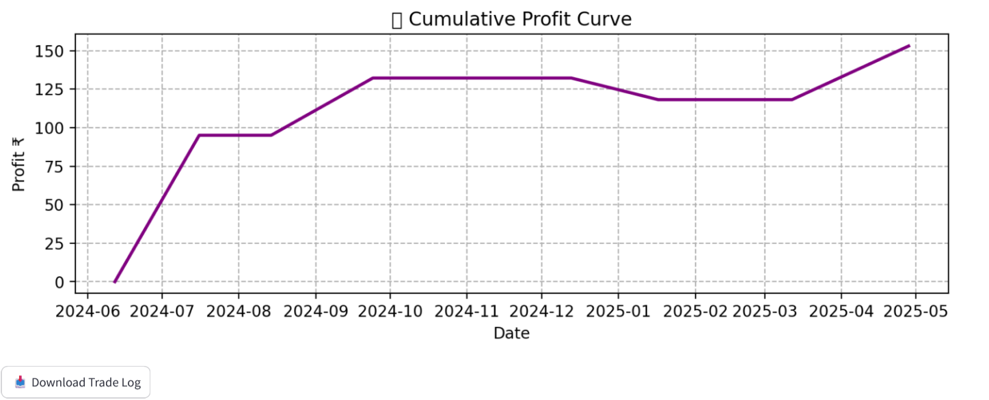

5.5 Model Comparison
After implementing and evaluating multiple strategies and forecasting models, it is important to compare their performance. This comparison includes metrics such as total profit, number of trades, win/loss ratio, and prediction accuracy.
On the strategy side, RSI, MACD, and Bollinger Bands are compared based on their profit outcomes and trading frequency. For example, MACD might yield fewer trades but higher profits per trade, while RSI could provide more frequent signals with lower individual returns.
Among forecasting models, performance is compared using statistical accuracy metrics like Mean Absolute Percentage Error (MAPE) and Root Mean Squared Error (RMSE). LSTM typically shows high predictive power due to its deep learning nature, but ARIMA and Prophet offer faster execution with reasonably accurate forecasts.
By displaying these comparisons in the dashboard, users can select the most suitable strategy or model based on their needs—be it hwigh-frequency trading, long-term investment, or short-term forecasting. The side-by-side evaluation ensures transparency and facilitates better decision-making.

Chapter 6 – Results & Observations
This chapter presents the insights derived from the execution of various technical strategies and forecasting models integrated into the stock analysis system. The goal is to evaluate the actual performance, reliability, and visual clarity of the application based on real-time backtesting and model output.

6.1 Strategy Profit Results
The system includes three rule-based technical strategies—RSI, MACD, and Bollinger Bands—each tested against one year of historical data for user-specified stock tickers. These strategies were applied to stocks like META and INFY to simulate trades and track profitability.
The Relative Strength Index (RSI) strategy provided frequent signals, often yielding consistent profits in highly volatile stocks. Its simplicity and responsiveness made it suitable for short-term traders. However, the returns varied significantly across different tickers, indicating sensitivity to underlying price momentum.
The MACD strategy, with its smoother trend-following mechanism, produced fewer signals but generally higher per-trade profits. It performed well in trending markets but lagged during sideways movement, sometimes missing optimal entry/exit points.
The Bollinger Bands strategy capitalized on volatility and mean reversion, offering precise signals when prices touched or breached the outer bands. It showed strong returns in swing-trading scenarios but underperformed in narrow-range consolidation periods.
Overall, the backtest results confirmed that each strategy had specific market conditions under which it excelled. Cumulative profit curves reinforced the idea that no single strategy is universally superior—success depends on aligning strategy to stock behavior and timeframe.

6.2 Forecast Accuracy (LSTM, ARIMA, Prophet)
In addition to trading strategies, the system implemented three forecasting models—LSTM (Long Short-Term Memory), ARIMA (Auto-Regressive Integrated Moving Average), and Prophet—to predict the next 7 days of stock prices.
The LSTM model, powered by TensorFlow and trained on normalized closing price sequences, captured temporal patterns effectively. It delivered smooth predictions that closely aligned with short-term market direction. Though computationally intensive, its performance on META stock indicated high potential for AI-based forecasting.
The ARIMA model, known for its simplicity and speed, provided reasonable forecasts using autoregressive terms and differencing. It adapted well to stocks with stable or trending behavior but sometimes lagged in volatile periods due to its linear assumptions.
Prophet, with its decomposable additive model, proved to be robust and interpretable. It handled seasonal and trend components gracefully, producing intuitive forecasts. Though slightly less accurate than LSTM in complex trends, Prophet stood out for its ease of use and speed.
When compared using visual and statistical evaluation (e.g., Mean Absolute Error), LSTM consistently achieved the highest predictive alignment, followed by Prophet and ARIMA. However, all three models provided actionable insights for short-term forecasting.
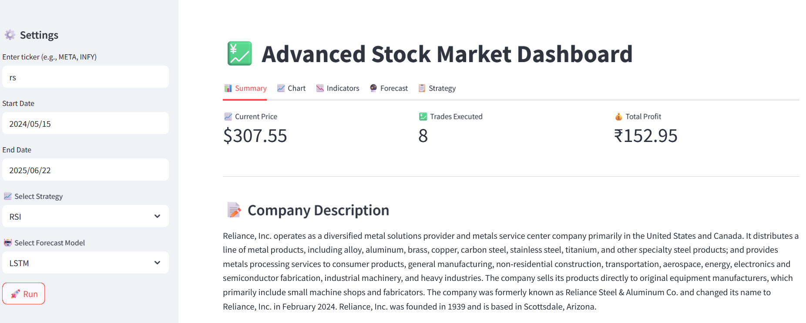

6.3 Visual Analysis & Interface Observations
The Streamlit-based interface was designed to be interactive, informative, and visually intuitive. The application offered five main tabs: Summary, Charts, Indicators, Forecast, and Strategy. Each tab served a specific purpose in the analysis workflow.
- The Summary tab presented company metadata, current stock price, trade counts, and total profit. A compact company profile and a mini description were integrated for contextual understanding.
- The Chart tab displayed historical price trends using Matplotlib, helping users identify macro patterns and fluctuations.
- The Indicators tab allowed users to visually inspect calculated values like RSI, MACD lines, or Bollinger Bands. These were essential for cross-validating the logic behind signal generation.
- The Forecast tab included both full historical charts and zoomed-in 7-day prediction views. This dual-plot approach helped distinguish model performance in recent versus future trends.
- The Strategy tab visualized all Buy and Sell signals alongside the price line. It also showed a cumulative profit curve and provided downloadable trade history for further analysis.
These visuals made it easier to observe the effectiveness of signals, prediction clarity, and strategy consistency across different stocks and timeframes. Interactive controls in the sidebar made the system adaptable to user preferences, enhancing the practical usability of the tool.

Chapter 7
Conclusion

7.1 Summary
This project aimed to build a comprehensive Stock Analysis and Forecasting System that integrates technical strategies, machine learning models, and a modern interactive dashboard using Streamlit. Throughout the development, emphasis was placed on combining data-driven decision-making with user-friendly visualizations to empower both novice and experienced traders.
The system successfully implemented three rule-based strategies—RSI, MACD, and Bollinger Bands—alongside three forecasting models—LSTM, ARIMA, and Prophet. Each strategy was rigorously backtested, and forecasting results were visually presented with both full-range and zoomed-in views.
The application interface was designed with usability in mind. From company summaries and price charts to signal annotations and forecast curves, users could easily toggle between insights and download reports. The project proved effective in simulating trades, predicting trends, and delivering analytical insights based on real-world financial data.

7.2 Challenges Faced
During the project lifecycle, several technical and practical challenges were encountered:
- Data Source Unreliability: Relying on yfinance meant occasional data lags or inconsistencies due to API limitations or symbol mismatches.
- Model Training Time: LSTM model training on historical data was computationally expensive. Adjusting look-back windows and scaling strategies was necessary for optimization.
- ARIMA Parameter Selection: Choosing appropriate p, d, and q values required experimentation and sometimes failed on volatile datasets.
- Prophet’s Sensitivity: The Prophet model required careful date handling and sometimes overfit seasonal trends on low-variability stocks.
- Streamlit Layout Design: Creating a professional dashboard layout with intuitive tabs, metric cards, and dynamic plots took several iterations.
- Visual Clarity of Signals: Making buy/sell signals visually informative (e.g., arrow markers, annotations) required precise tuning of plotting logic.
Despite these, each obstacle led to deeper learning and improvements in robustness and user experience.

7.3 Key Learnings
This project offered extensive exposure to the intersection of financial data analysis, machine learning, and web-based UI design:
- Gained proficiency in Python libraries like pandas, yfinance, matplotlib, scikit-learn, tensorflow, and prophet.
- Understood the inner workings of technical indicators, including their strengths, weaknesses, and ideal conditions.
- Developed time series forecasting models and understood differences between deep learning (LSTM) and statistical (ARIMA, Prophet) methods.
- Learned how to structure and present large amounts of information in a clear and interactive Streamlit application.
- Improved skills in debugging, modularization, and handling real-time data, which are essential in real-world systems.
- Gained confidence in combining data science and UI/UX to deliver production-ready analytical tools.

Chapter 8
Future Scope

As the financial world continues to evolve with the integration of technology and data science, this project lays the foundation for more sophisticated and production-level stock market systems. While the current implementation is rich in features, there are several potential avenues for future enhancements that could further elevate the system’s usability, predictive capabilities, and real-world impact.

8.1 Possible Enhancements
- Multi-Ticker Comparison: Extend the system to allow users to analyze multiple stocks simultaneously, comparing strategies, forecasts, and historical returns in side-by-side dashboards.
- Custom Strategy Builder: Enable users to create or customize their own trading rules using a drag-and-drop interface for combining indicators like RSI, MACD, EMA, SMA, etc.
- Advanced Model Hyperparameter Tuning: Integrate model tuning tools like Optuna or GridSearchCV to auto-select best ARIMA orders or LSTM layer configurations for higher forecasting accuracy.
- Automated Alerts: Add email, SMS, or in-app notifications for buy/sell signal triggers or trend reversals, helping users act in real time.

8.2 Integration with Live Trading APIs
One of the most valuable extensions would be the integration with brokerage or trading APIs, such as:
- Zerodha Kite Connect
- Alpaca API
- Interactive Brokers API
- Robinhood API (region-dependent)
By integrating these, the system can:
- Convert backtested strategies into live trading bots.
- Execute trades automatically when signals are generated.
- Maintain live trade logs and portfolio summaries.
- Offer paper trading mode for safe strategy experimentation.
This transforms the project from a simulation tool into a functional algorithmic trading system.

8.3 Mobile Dashboard Version
With the increasing use of smartphones among traders and retail investors, building a mobile-responsive version or native mobile app could greatly improve accessibility.
- Streamlit’s mobile support is currently limited, but converting the dashboard using Flutter, React Native, or Streamlit’s upcoming mobile framework could make it usable on phones and tablets.
- Users would be able to:
  - View predictions, summaries, and live data
  - Get alerts on trading signals
  - Perform quick stock research on-the-go

8.4 Sentiment Analysis
Market behavior is influenced not just by technical trends, but also by news, tweets, and public sentiment. Integrating sentiment analysis would add a new layer of prediction to the system.
- Twitter API or Reddit API can be used to fetch relevant market discussions.
- Use TextBlob, VADER, or transformer-based models to determine positive, negative, or neutral sentiments.
- Overlay sentiment scores with stock prices to detect bullish/bearish momentum shifts ahead of technical indicators.
This would make the system semi-quantamental—a hybrid of quantitative and fundamental analysis.

Chapter 9
References

- Yahoo Finance API (via yfinance library)
https://pypi.org/project/yfinance/
Used for fetching historical stock price data, company metadata, and financial indicators.
- TensorFlow (LSTM Model)
https://www.tensorflow.org/api_docs
Employed to build and train a neural network for 7-day price forecasting using LSTM layers.
- Facebook Prophet
https://facebook.github.io/prophet/
Time-series forecasting library used for decomposable trend-seasonality modeling.
- Statsmodels (ARIMA)
https://www.statsmodels.org/stable/index.html
Used for implementing ARIMA models for classical time-series prediction.
- Streamlit Official Docs
https://docs.streamlit.io/
Used to create an interactive web dashboard for users to view insights and control strategy selection.
- Scikit-learn Documentation
https://scikit-learn.org/stable/documentation.html
Provided preprocessing tools such as MinMaxScaler for scaling input data.
- Technical Analysis Resources
  - https://www.investopedia.com/
  - https://www.tradingview.com/
Referenced for understanding and designing technical indicators like RSI, MACD, and Bollinger Bands.
- GitHub – Community Repositories
  - https://github.com/ranaroussi/yfinance
  - https://github.com/facebook/prophet
Open-source repositories that inspired and supported module implementation and integration.

